Tonata PLHIV Network
  - Organizational Profile

Introduction
Tonata is a dynamic network of People Living with and affected by HIV/AIDS (PLHIV), founded in 2008. ‘Tonata,’ meaning “open your eyes” in Oshiwambo, seeks to ensure that civil society organizations and community groups and networks are supported to better organize and coordinate themselves for strengthening resilient and sustainable systems of health. This community-led organization operates in six regions across Namibia and maintains a network of over 29,000 people living with HIV (PLHIV), with wider outreach of vulnerable groups—including people with disabilities (PWD), adolescent girls and young women (AGYW), adolescent boys and young men (ABYM), members of the LGBTQ community, survivors of gender-based violence, etc. Tonata’s primary areas of focus include building and strengthening community systems; advocating for legal and policy reform; delivering key health education; promoting economic empowerment; reducing stigma and discrimination; promoting gender equality. Tonata has established strong working ties with key stakeholders, including governmental institutions (e.g., MoHSS, RACOC, Ministry of Gender, etc), civil society organizations and advocacy groups (e.g., NFPDN, IntraHealth, DAPP, etc), local authorities (e.g., traditional leaders and faith-based organizations), and other relevant institutions, strengthening our position in the field.

Our Vision, Mission, & Values
- Vision: “a free society, strong voice for PLHIV, and ensured quality of life.” Every person has the fundamental right to health and justice. We support a movement grounded in dignity, rights, and solidarity.
- Mission: to provide and maintain a network of support groups and advocate for people living with and affected by HIV/AIDS.
- Core Values: equality; transparency and accountability; collaboration; unity of purpose; trust & respect.

Our Impact
Over the past 17 years, TONATA has significantly improved the lives of people living with HIV (PLHIV) and other key populations in Namibia through advocacy, support, and empowerment. Our network has expanded to include over 1,300 support groups with more than 29,000 members provided with peer counseling and mutual support for positive living. Our support groups play a transformative role by leveraging networks of peers, communities, and health workers. Tonata trains group leaders in our community adherence groups (CAGs) to collect and distribute ARVs within communities, reducing travel costs and treatment default rates. CAGs are powerful in driving the HIV response as enshrined in the National Strategic Framework, while contributing to the achievement of the UNAIDS’ 95-95-95 targets. Our support groups also engage local leaders and represent PLHIV at national platforms, including CACOCs, RACOCs, and the National AIDS Coordinating Committee, ensuring their concerns reach policymakers. Committed to empowerment, we promote income-generating activities and Village Saving and Loans (VSL) systems within our support groups, which boost financial independence and commitment to group activities. By addressing financial barriers to healthcare, VSL increases group resilience, leading to better health outcomes.

Why We Matter
Our network responds to a ‘need’ for continued networking and meaningful engagement of people living with HIV (PLHIV) in activities that concern and improve their lives. The Network has a proven track record & experience in implementing similar programs & projects for the past 18 years. We are a locally founded organization operating in Namibia whose constituents and top leadership are themselves living and affected by the HIV epidemic.

Tonata’s Approach to Health Equity and Justice

Support Group Model
Ownership is a cornerstone principle in our support group (SG) model, empowering members to take responsibility for their own health while fostering a culture of mutual support. This approach enables individuals to actively participate in their health journey, supported by their peers and the broader community. In Namibia’s high HIV prevalence rural areas, SGs play a transformative role by leveraging networks of peers, communities, and health workers to:
- Promote HIV Testing: Normalizing discussions and reducing stigma to encourage testing.
- Facilitate Linkage to Care: Connecting individuals to health services promptly.
- Improve Treatment Retention: Providing ongoing support to overcome adherence challenges.
Ownership also extends to the sustainability of the SGs themselves. Members actively participate in group governance, decision-making, and problem-solving, which strengthens their commitment and ensures that the SGs remain functional and relevant over time. SGs also serve as a vessel to uplift voices:
- Support groups meet with local leaders, including headmen, councilors, and governors, to share their challenges.
- They are represented at national platforms like the CACOS, RACOCs and National AIDS Coordinating Committee, making sure their issues reach Parliament.
Support Groups serve to provide emotional support, act as a platform for advocacy, prevent stigma and discrimination, provide economic opportunities, as well as provide practical help.

Community Adherence Groups
Community adherence groups (CAGs) have brought ARVs closer to communities. Long hospital queues and high transport costs have made it difficult for people to obtain their ARVs in a timely manner. Tonata has trained support groups to self-organize themselves into CAGs. In this system, contributions by the group make it possible for leaders to collect ARVs from hospitals and distribute them to group members. The CAG system has reduced treatment default rates and saved lives.

Collaboration with Stakeholders
Collaboration with stakeholders has proven to be a vital strategy for strengthening the sustainability, reach, and impact of the HIV response. Fostering partnerships across sectors has enhanced community engagement, improved service delivery, and promoted ownership at both local and regional levels. Through joint planning and implementation, stakeholders have supported capacity building, community mobilization, and the integration of essential health services. These partnerships have enabled effective knowledge sharing, helped address service gaps, and increased access to health information. The collective effort has also created opportunities for income generation, leadership development, and broader public awareness. Engaging traditional and local leaders has been especially valuable in fostering trust, reducing stigma, and mobilizing communities. Their influence and endorsement have encouraged broader participation. Such collaboration demonstrates the value of multi-sectoral engagement in achieving a more coordinated and community-driven response to HIV and AIDS—one that is sustainable, inclusive, and responsive to local needs.

Capacity Building
Capacity-building plays a critical role in enhancing the effectiveness of community-led intervention. All Tonata programming begins with—and is continuously supported by—mobilizer trainings, which strengthen their ability to engage communities effectively. Trainings focus on developing skills in the following areas:
- Health promotion: mobilizers are equipped with in-depth knowledge about key health topics and trained to communicate effectively about how these issues affect the community, ensuring consistent and accurate messaging
- Community Engagement and Advocacy: Mobilizers are trained to strengthen their engagement with communities, fostering trust and creating awareness about health promotion and economic opportunities. They are also prepared to address barriers such as stigma, misinformation, and logistical challenges.
- Economic Strengthening Initiatives: Recognizing the link between economic stability and health outcomes, the trainings include sessions on economic strengthening strategies. Mobilizers are taught how to promote sustainable economic activities within support groups, such as Village Savings and Loan (VSL) systems, which empower members to improve their livelihoods.
Investing in the skills development of community health workers is critical for an effective and sustainable HIV response. It not only recognizes the leadership of communities in driving health systems but also equips them to do so effectively.

Economic Empowerment Activities

Income-Generating Activities
Aside from delivering health education and mobilizing engagement in the health system, we empower our communities with income-generating activity (IGA) trainings, including gardening, farming, poultry management, food production, and clothing production. We leverage partnerships to secure capacity building for our support groups, such as engaging constituency offices for jam production trainings. Similarly, we assist support groups to successfully engage local authorities (e.g., headmen) for support in establishing and expanding their IGAs, such as with donations of land or funds.

Village Savings and Loan
A Village Savings and Loan Group (VSLG) is a group of 10–25 people who save together and take small loans from those savings. The activities of the VLSG run in ‘cycles’ of about one year, after which the accumulated savings and profits are shared out among the members according to the amount. VSL has been proven to boost financial independence and reduce financial barriers to healthcare, which increases group resilience and leads to better health outcomes. VSL also strengthens commitment to group activities, including communal IGAs, among support group members, promoting greater health outcomes and economic advancement

Community ART Services (Past Successes)
- Conduct advocacy and social mobilization to facilitate the achievement of national ARV provision and the strengthening of community-based monitoring services.
- Ensure implementation of a communication and advocacy strategy for various audiences on relevant health topics (e.g., HIV communications, stigma, and disclosure).
- Train support group members to increase access to local support groups within the confines of ARV provision, community-based monitoring services, and strengthening of community-based system objectives.
- Establish and strengthen the relationships between clinic personnel and support group leaders.
- Provide traditional authorities with the development of a referral mechanisms between CAG groups and health facilities.
- Support the establishment of limited and targeted linkages between CAG groups and RACOCs.
- Work with MoHSS health facilities, hospitals, clinics and pharmacy personnel to increase client convenience for appointment spacing and fast-track drug refills.
- Collect and refill ARVs, record pill count, and trace clients who fail to refill their ARVs.
- Develop a linkage and referral system to connect all PLHIV in a community with facilities for ARV initiation and provision.
- Provide counselling for clients with alcohol and/or other substance abuse
- Conduct voluntary and consensual sexual partner notification and referral (i.e., index- case finding).
- Establish provider care teams and networks that include facility nurses, pharmacists, data clerks,CSG lead, and expert patients.
- Ensure that all stable PLHIV in support groups have access to VL testing, documentation of results, and are followed by CSG or the network.

Roadmap of Our Approach
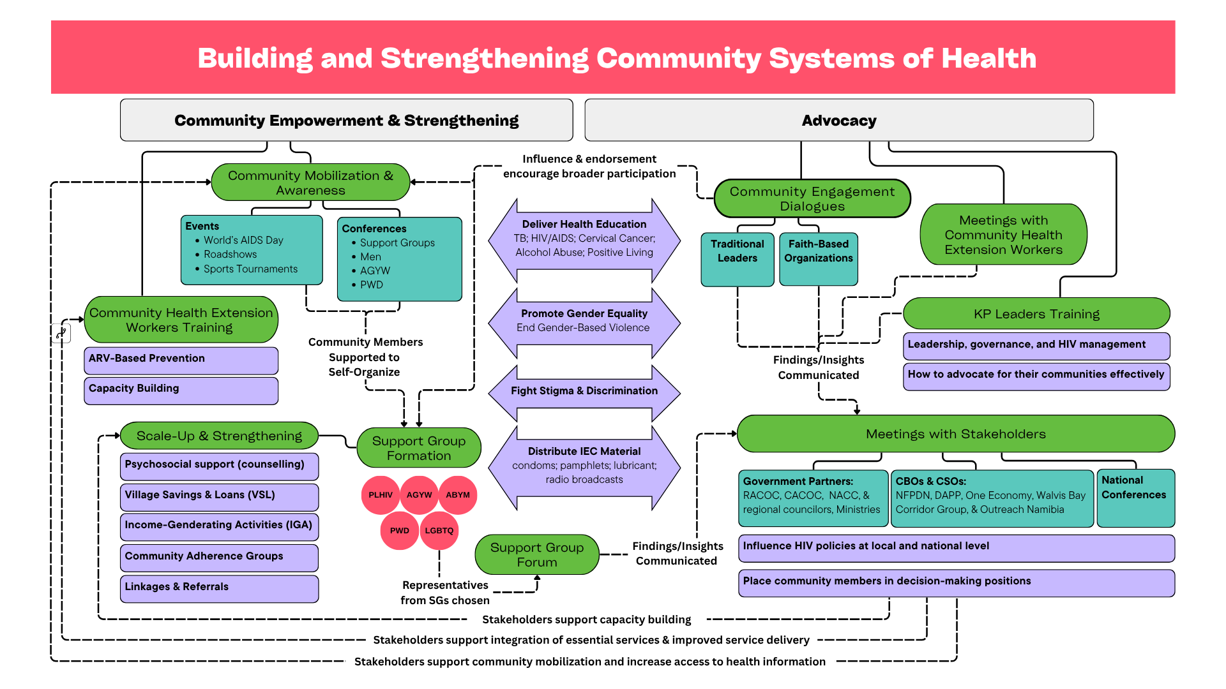

Our Past and Current Projects
Project Name | Donor | Period of Activity
Strengthening Resilient and Sustainable Systems of Health and Community System Strengthening | Global Fund/MoHSS | 2024-2026
Gender Assessment Project | UNAIDS | 2024; 2025
Support Group and Community Adherence Group Strengthening Project | CDC/TCE/DAPP | 2023-2025
Cervical Cancer Prevention Project | UNAIDS/MoHSS | 2024-2025
FRIEND – Community-Based ART Differentiated Delivery Service | CDC/MoHSS | 2020-2022
Community-Based HIV Treatment Services | USAID | 2018-2023  *Ended in 2020 due to reprogramming
Consulting Services of Project Area Inhabitants on Communicable Diseases (HIV/AIDS & STI) | PEPFAR - USAID | 2018-2020
Namibia Adherence and Retention Project | USAID/Project Hope | 2016-2017
Communication and Advocacy | GIZ | 2014-2016
Building Local Capacity Project | USAID/ Management Sciences for Health | 2015
Community-Based Palliative Care Initiate Support Group Roll-Out | USAID/African Palliative Care Association | 2014-2015
Children’s Voice | European Union | 2008-2010

Regions of Operation
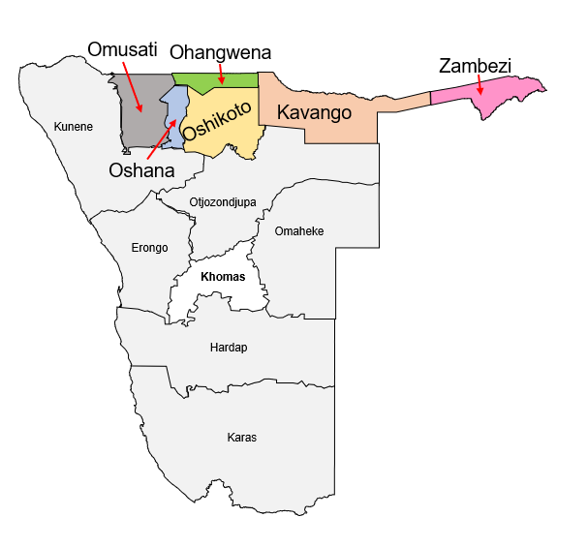

Our Team

As we work towards achieving the goal of ending HIV/AIDS as a public health threat by 2030, it is crucial to ensure the long-term sustainability of the HIV response. Achieving this goal requires transformative actions in policy, programs and systems. It also demands a clear vision, early planning and strategic approaches to address access to health services and strengthening community systems for health. Our well-established team brings proven expertise in health education and community empowerment to support these efforts. In collaboration with key partners, we utilize a community-based, bottom-up approach to engage communities and diverse groups. This ensures that local voices shape solutions and drive meaningful change.

Organizational Structure
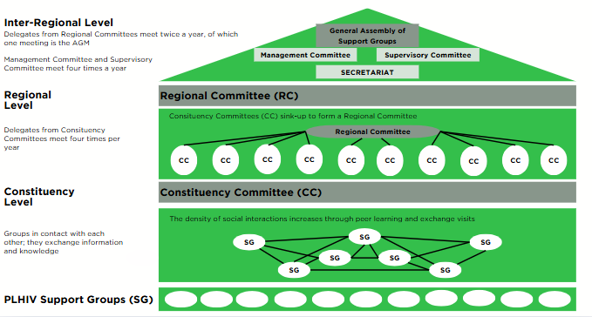

Executive Team

HR Structure
Executive Director
┌───────────┴────────────────────┐
Deputy Director Finance & Administration Manager
│ │
┌────────────────┐ Finance & Admin Assistant
M&E Officer Advocacy & Communication Officer
│
Advocacy, Communication, & Branding Assistant

Key Personnel

Executive Director – Ms. Victoria Kamule
Ms. Victoria Kamule serves as Executive Director of Tonata PLHIV Network. In this role, she oversees the coordination and management of the support groups, including liaising and representing the Network at all decision-making platforms. As Project Oversight, Ms. Kamule is responsible for leading and supervising all technical aspects of the programs (i.e. design, implementation, monitoring and evaluation of the community HIV response) as well as providing oversight of the programs’ administration and financial management. Her role as ED involves supervising and leading the entire executive team.
Victoria Kamule is one of the founders of Tonata and has over 25 years of experience working with communities across Namibia on topics related to public health and HIV/AIDS. She is an experienced counsellor—providing physical, emotional and psychosocial support to PLHIV and other vulnerable populations—with expertise in community advocacy and -based differentiated service delivery, TB, malaria, gender issues including reproductive health and human rights.

Deputy Director – Mr. Nehemia Paulus
Mr. Nehemia P Paulus serves as Deputy Director of Tonata. In this role, he oversees the operational management and strategic planning of all program activities to ensure alignment with organizational goals. Mr. Paulus is also responsible for staff supervision and mentorship and provides specific leadership in the Communication and Advocacy department.
Mr. Paulus is one of the founding members of Tonata PLHIV Network. He is an experienced professional in the world of community-based organizations, with over 35 years of experience working in the civil society sector in Namibia. Mr. Paulus has a strong technical background working with support groups of people living with or directly affected by HIV/AIDS, including his involvement with community-based ART initiatives. Mr. Paulus has supported Tonata PLHIV Network to develop systems and structures that better mobilize resources, strengthen partnerships and bolster transparency.

Finance & Administration Manager – Mr. Faustinus Mushelenga
Mr. Faustinus Mushelenga serves as Finance & Admin Manager of Tonata. His role involves maintaining all accounts and financial records of Tonata; accurately recording and monitoring all daily financial transactions in accordance with GAAP and Tonata’s policies, procedures, and organizational guidelines; preparing budgets; managing and reconciling accounts payable and receivable; preparing payment requisitions; assisting with internal and external audits; generating financial reports; maintaining a complete filing system to support the financial records and transactions of Tonata.
Mr. Mushelenga has over 10 years of working experience in accounting, finance and administration, with expertise in donor-funded and Namibian government programs.

Communication & Advocacy Officer – Ms. Taimi Amukwaya
Ms. Taimi Amukwaya serves as Tonata’s Communication & Advocacy Officer, responsible for planning and coordinating support to ensure the effective implementation of communication and advocacy activities in close collaboration with project teams. She develops informational materials and tools for Tonata’s programs and communicating key information to stakeholders. Ms. Taimi also promotes the work of Tonata in Namibia and coordinates advocacy efforts with government program clusters—including the MoHSS, traditional authorities, RACOC, and other civil society organizations.

Ms. Taimi brings more than 20 years of experience in community development, program and
financial management, counselling, economic strengthening. She has expertise in training and mentoring community health workers on a range of topics—including family-centered approaches, HIV/AIDS, TB, and gender-based violence. Ms. Taimi has successfully led community development initiatives across Omusati, Oshana, Oshikoto, Ohangwena, Kavango East and West, and Zambezi Regions. She is also well-versed in monitoring and evaluation.

Monitoring & Evaluation Officer – Ms. Filipina Lukas
Ms. Filipina Lukas serves as Tonata’s M&E officer. Ms. Lukas is responsible for leading the design and implementation of our community response projects, developing information systems for tracking delivery against targets of the project activities, as well as overall monitoring and evaluation. This role involves close communication and coordination with other technical and operational staff, including the Communication & Advocacy Department and our field staff. Ms. Lukas is also responsible for overseeing the implementation of community mobilizations, advocacy, and trainings at regional levels.
Ms. Filipina has over 15 years of professional experience in project management, specifically in the areas of HIV/AIDS, tuberculosis (TB), counselling, and gender-based violence programs. With a focus on the sustainability of community programs and structures, she has led development and advocacy initiatives across Ohangwena, Oshana, Omusati, Oshikoto, Otjozondjupa, Zambezi, and both Kavango East and West regions.

Board Goals, Role, & Structure
Our board is primarily comprised of PLHIV. Involving PLHIV in key positions of guidance and decision-making ensures that Tonata continuously meets its goal of serving our support group network and reaching the communities at large.
- Goals: to ensure the organization’s funds and resources are allocated to interventions and activities that enable Tonata to achieve its vision, mission, and objectives in a manner best serving the interests of the members of support groups of people living with or directly affected by HIV.
- Roles & Responsibility: to effectively represent and promote the interests of Tonata’s beneficiaries, ensuring the long-term efficacy and sustainability of the organization; to direct and supervise the management of the network and affairs of the organization.
- Structure:
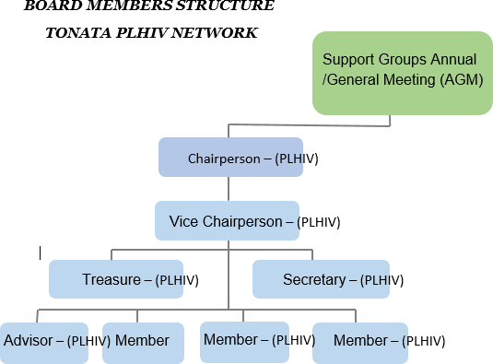

Key Management Systems:

Monitoring & Evaluation Systems
Tonata’s M&E Framework and policy document guide how our projects, programs, and activities are monitored and evaluated, with data stored in a digital database.
The M&E framework outlines how each activity is measured in terms of performance and impact.
Key highlights of the M&E policy include:
- Data Collection, Analysis & Information Generation: data is entered and stored in an automated database, ensuring that analysis and reporting inform decision-making and program improvement. Data collection is conducted at the regional level by our Regional Liaison Officers (RLO). Analysis and reporting is conducted on a quarterly basis.
- Data Quality Assurance: TONATA undertakes routine data verification and auditing. Results from Tonata’s community-led activities (qualitative and quantitative) are disseminated on the organization’s website (www.tonata.net).
- Program Evaluations: Tonata’s evaluations (covering process, outcome, and impact) are conducted in alignment with the terms and conditions specified in the agreement with the funding partner.

Financial Management Systems

Overview
Tonata’s Financial and Administrative Policy and Procedures Manual serves as the principal guide for administration and management of the organization’s finances. The manual is used by the Finance & Admin department during daily operational duties. Pastel Accounting and Pastel Payroll (2018 version) is used to record accounting data and to process remuneration of staff. An asset register is kept by Tonata through an assets management software, with all assets tagged and labeled. A live fleet monitoring system is used to track field vehicle’s movements. Vehicles are filled using an FNB fleet petrol management system. An Electronic payment system is used to process transactional activities of the organization.

Segregation of Duties
Financial duties are distributed among accounting/financial personnel in a manner that ensures one person does not have control over all phases of a financial transaction. To accomplish proper segregation of duties, different individuals perform different functions, such as authorizing transactions; recording transactions; maintaining custody of the assets that result from a transaction; comparing assets with the related amounts recorded in the accounting records. Additionally, a senior official approves expenditures prior to their execution, examines expenditure documentation, signs off on EFTs, as well as reviews and approve the bank reconciliation reports.

A careful distribution of duties prevents situations in which illegal acts or violations of rules could be carried out and concealed (e.g. the person who authorizes purchases or expenditures does not issue the payments to vendors; the person who issues the checks and payments does not reconcile the cash and bank accounts).

Internal Controls
Among other controls, below is brief summary of our internal controls to ensure that prudent financial management of the organizational financial resources is exercised at all times.
- Financial responsibilities and level of authority are defined in employee job descriptions;
  - Written procedures are maintained with financial and accounting practices, account coding, and activity coding schemes. This procedure includes policies on travel, personnel and procurement practices.
- Safeguards and policies are in place to guard against conflict of interest;
  - Expenses are controlled through the use of operating budgets, purchase orders, and travel authorization. These systems are documented and uniformly applied.
- Cash and expenses are segregated by donor fund or contract, if applicable;
  - Subsidiary accounts (Accounts Payable, Accounts Receivable, Advances, Cash Accounts) are reconciled to the General Ledger monthly.
- Contingent upon the availability of funds, financial records are subjected to both external and internal audits, at a minimum of once per fiscal year. All variances and issues must be documented and reconciled promptly and disciplinary action must be taken when warranted;
  - Journal entries and cash adjustments require approval.
- Cash receipts are deposited promptly;
  - Payments are executed only with the appropriate approval and upon submission of the required documentation (e.g., detailed invoices, copies of purchase orders, shipping documents, etc.).
- Procurement policies are documented and applied consistently to ensure fair and open competition to the greatest extent possible. Best value is considered, including price, quality, service and warranty or goods or services;
  - Purchasing functions are kept separate from accounting functions.
- Payments for salaries and wages must be substantiated by signed and approved timesheets, detailed calculations of withholdings and allowances, and proof of approved pay rates and changes in pay;
  - Systems are in place to ensure that dismissed employees are not paid after a payout of final wages or accrued vacation or severance; charges to donor funds may be tied to the actual benefits received by the donor.
- Policies are documented and applied to ensure that only allowable costs are incurred when donor funds are being used;
  - Records are maintained of any prior approval required by donor agreement, which may include approval for international travel, purchase of equipment, or salaries.
- Systems are in place to ensure the appropriate business use of supplies, equipment and other assets;
  - Property and other assets are protected or ensured against theft, fraud, fire or other catastrophic loss to the greatest extent possible. Physical inventories are undertaken at least once per year to verify the location and condition of all assets.
- Systems are in place to ensure that computerized financial records are backed up and archived for future reference. Computer files are protected from damage caused by power outages and surges, to the extent possible;
  - Paper documents are maintained in an orderly manner and kept on file for the mandated number of years to satisfy audit or donor requirements. Paper files should be protected from fire and water damage to the greatest extent possible.

