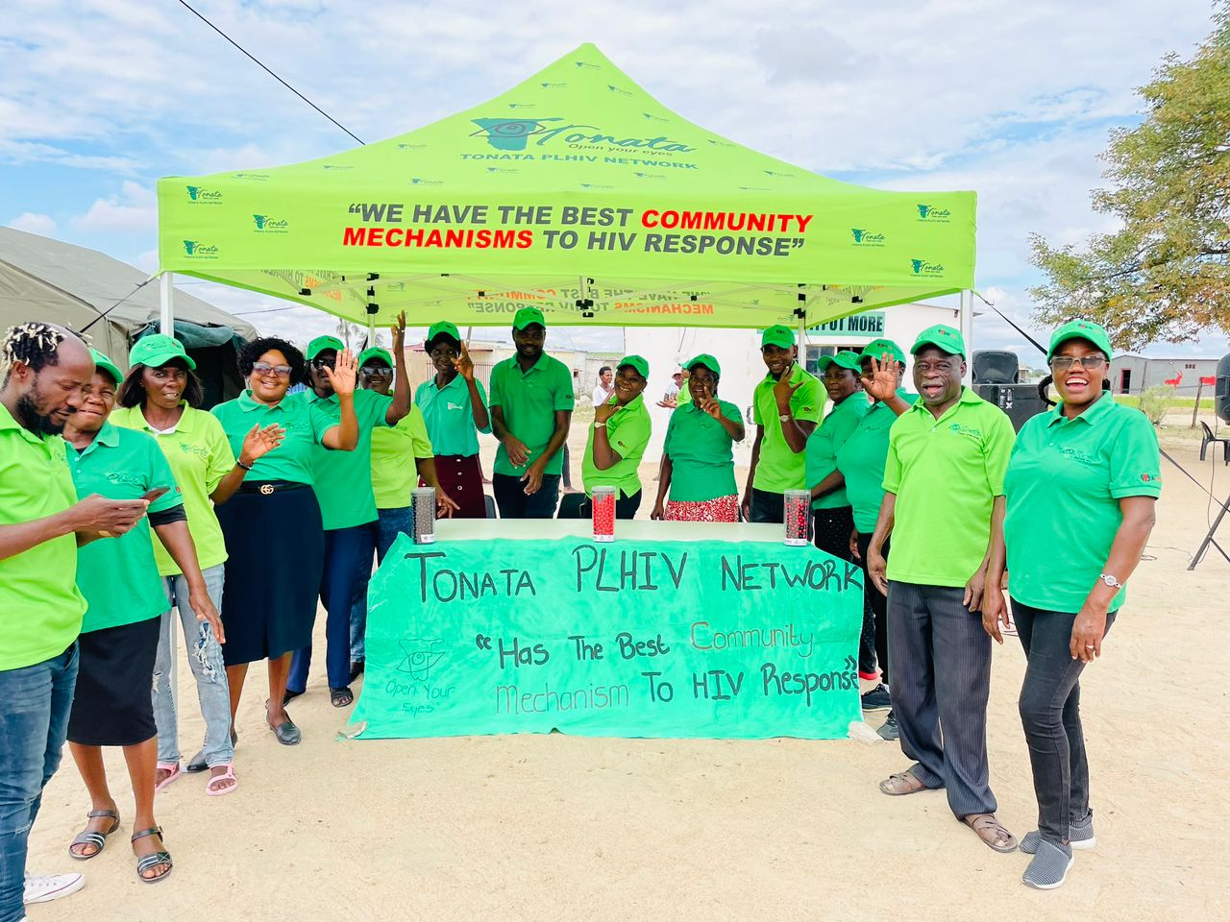
Employment Opportunities with Tonata PLHIV Network

VACANCIES

TONATA PLHIV Network is a dynamic network of People Living with HIV (PLHIV) that seeks to improve the lives of those with HIV through support groups. These support groups have many benefits one of which is the possibility of PLHIV to engage with regional level decision-making in a meaningful way. To date, TONATA has a nationwide network of over 29,000 PLHIV as their members. The organization utilizes community-based approaches in building the strength of support groups and implementing a variety of communication and advocacy activities throughout Namibia.


Project Objective: In collaboration with the Ministry of Health and Social Services and with financial support from Global Fund, the Tonata PLHIV Network is undertaking a community-lead project in selected regions: Zambezi, Oshana, Kavango East, Oshikoto, Omusati and Ohangwena, The project is expected to Build Resilient and Sustainable System for Health and Community System strengthening through community lead initiative.

- Position: M&E Officer x1
Reporting to: Project Lead/Manager
Duty station: Tonata head office in Ongwediva, Oshana region

Job Summary: The M&E Officer will be responsible for leading the design and implementation of the Resilient and Sustainable System for Health and Community System Strengthening project, monitoring and evaluation and information system to track delivery against targets of the project activities.

Contract Duration: 8 months (June to December 2026), with the possibility of extension depending on funding availability.

MINIMUM EDUCATION AND EXPERIENCE REQUIRED:

- Bachelor’s degree in Public Health or social science or related area.
- Minimum of three years’ professional experience in planning and management of Health or HIV related M&E programs.
- Experience in gathering, recording, analyzing and reporting information needed for M&E strengthening and management.
- Knowledge and experience in Global Fund (GF) M&E Systems or donor agencies is required.
- Proven ICT Skills in Microsoft Office and Data base management on at least one of the following, Excel, EPI info, SPSS, SAS, STATA and web-based data base.
- Good research and analytical skills.
- Good communication and inter-personal skills, a team player, able to work under minimum supervision in a fast-paced environment.
- Ability to take initiative, conceptualize, plan and monitor activity flow and outcomes.
- Namibian citizen or permanent residency.
- Ability and willingness to travel in rural areas of Namibia.
- Must hold a valid Code BE Driving license.
- PLHIV and other minorities, e.g., women, are encouraged to apply.

- Position: Regional Community Liaison Officer x 1
Reporting to: Advocacy and Communications Officer
Duty station: Ohangwena region

Job Summary of responsibilities: Main functions will be supporting the Resilient and Sustainable System for Health and Community System strengthening through community lead initiative project in carrying out activities, interacting and sensitizing HIV service users on the community lead approach; serving as a link between the stakeholders and community at regional level.

Contract Duration: 8 months (June to December 2026), with the possibility of extension depending on funding availability.

MINIMUM REQUIREMENTS (skills, abilities and qualifications):
- Minimum of grade 10 certificate.
- Fluent in both written and spoken English, as well as in at least one local language of the assigned region.
- Previous experience working in the HIV field, with a comprehensive understanding and knowledge of HIV prevention and treatment as an added advantage.
- Strong organizational, multi- tasking and management skills.
- Trustworthy, excellent interpersonal and communication skills and demonstrated ability to be a team player.
- A good knowledge of the social, cultural, political, and economic background of the region.
- Be Namibian or permanent resident.

Interested candidates should send CV & cover letter to:

Email: HR Department – nehemiapp@gmail.com

Or hand-deliver to:

TONATA PLHIV Network Office
Puukali Properties, ERF 3264, Auguste Taanyanda Street, Unit 4, Ongwediva, 15006, Oshana, NA

ONLY SHORTLISTED CANDIDATES WILL BE CONTACTED

For more information, please contact:
Faustinus Mushelenga @ 0817649794 or N.P Paulus @ 0813377698

Closing Date:
Friday 8 May 2026 @ 12:00

